# Enhancing Music Experience Through Playlist Recommendation Systems

Varun Narsana  
Department of Computer Science

and Engineering

Lovely Professional University  
Punjab, India  
varun.narasna@lpu.in

# *Abstract:*

The rising popularity of music streaming platforms has emphasized the demand for effective and personalized playlist recommendation systems. These systems enhance user experience by delivering music suggestions tailored to individual preferences, fostering user engagement, and driving platform retention. This paper provides an in-depth examination of playlist recommendation systems, focusing on prominent techniques such as collaborative filtering, content-based filtering, and hybrid models. Through a comparative analysis, we assess the effectiveness of each approach in enhancing recommendation quality, addressing challenges like data sparsity, and minimizing cold-start issues. The findings underscore the potential of advanced models in delivering meaningful, accurate, and contextually relevant recommendations. This study also highlights the implications for future work in refining these models to incorporate real-time and contextual data for further improvement.

*Keywords:* Playlist Recommendation System, Collaborative Filtering, Content-Based Filtering, Hybrid Models, Machine Learning, Personalization

*Introduction:* With the exponential growth in digital music consumption, music streaming platforms like Spotify, Apple Music, and YouTube Music have become a primary source for users to discover and enjoy new content. A key feature enabling these platforms to retain users is the playlist recommendation system, which personalizes music suggestions based on individual user preferences. However, developing accurate and relevant recommendations is complex, often involving a blend of various machine learning techniques. This paper seeks to address the intricacies of these systems, exploring methodologies to enhance their

effectiveness. Sections in this paper cover the scope of the playlist recommendation field, the methodologies applied, and an evaluation of system performance

II. Literature Review: **Matrix Factorization Techniques**  
Matrix factorization is one of the foundational advancements in collaborative filtering, designed to decompose a large user-item matrix into smaller matrices that capture latent features. Popularized by models like **Singular Value Decomposition (SVD)**, matrix factorization uncovers patterns in sparse data by reducing dimensions, making it easier to identify user preferences. SVD, in particular, has shown success in applications such as the Netflix Prize competition, where it achieved notable accuracy improvements by factoring in user and item biases. Other variations, like **Non-negative Matrix Factorization (NMF)**, further enhance interpretability, as they restrict factorized values to non-negative numbers, aligning with real-world scenarios where preferences cannot be negative.

**Neural Collaborative Filtering (NCF)**  
Neural collaborative filtering leverages neural networks to model user-item interactions in a non-linear fashion, going beyond the linear relationships found in traditional methods. In NCF, user and item embeddings are learned through a series of hidden layers, allowing the model to capture complex dependencies and nuanced preferences. One advantage of NCF is its ability to learn hierarchical representations of user preferences, providing flexibility and scalability for large datasets in platforms like music streaming services. The method has been particularly beneficial in addressing non-trivial interaction patterns that standard collaborative filtering might overlook.

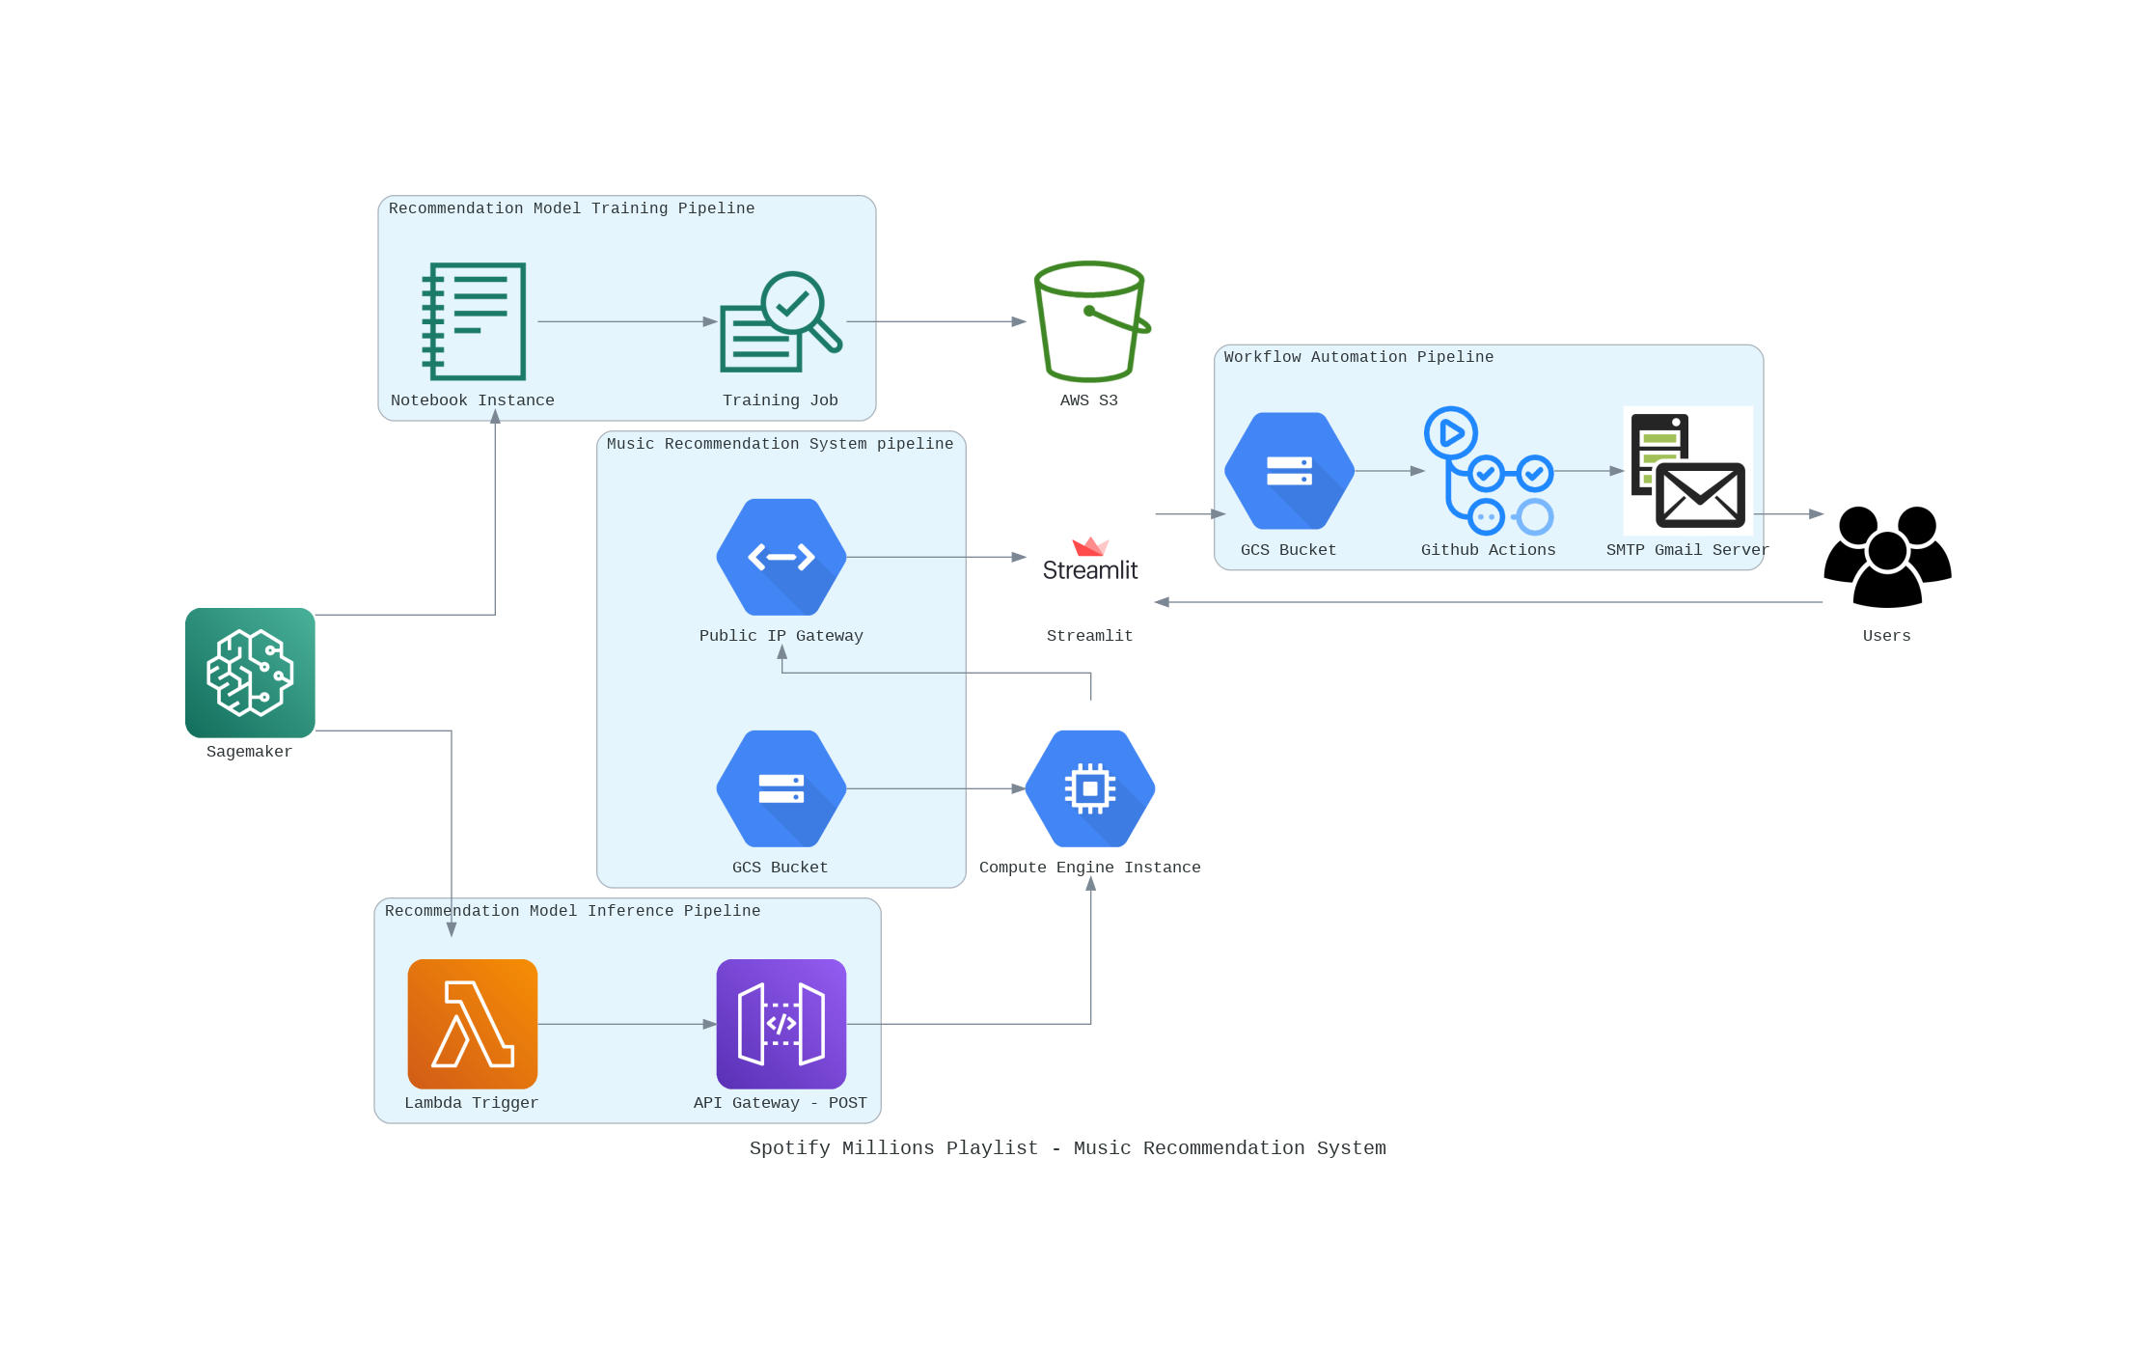

**Variational Autoencoders (VAE)**  
Variational autoencoders represent another sophisticated approach, commonly applied in recommendation systems to capture hidden representations of users and items. VAEs create a probabilistic model for the data, learning a latent space where similar users and items cluster together. This technique helps in generating new recommendations even in data-sparse scenarios by leveraging the learned distributions. VAEs are effective for content-rich domains, such as music and video streaming, where recommendations benefit from a high-dimensional representation of both users and items.

**Content-Based Deep Learning Models**  
Deep learning models like **Convolutional Neural Networks (CNNs)** and **Recurrent Neural Networks (RNNs)** have transformed content-based recommendation approaches. In music recommendation, CNNs are used to extract intricate audio features like tempo, pitch, and rhythm, which are then compared to users' past interactions. RNNs, on the other hand, are effective in sequential recommendation tasks, analyzing a user’s listening history as a sequence to predict future preferences. These deep learning methods not only enhance the ability to understand content but also allow systems to handle complex media data that goes beyond simple metadata, thus improving recommendation accuracy.

**Hybrid Models with Ensemble Learning**  
Hybrid models, which integrate both collaborative and content-based techniques, address many limitations faced by each individual approach, such as cold-start problems or limited diversity. Ensemble methods in hybrid models assign weights to different recommendations, combining predictions from various algorithms to improve overall accuracy. For example, hybrid systems might weigh collaborative filtering results higher for long-term users with abundant data, while relying more on content-based predictions for new users. This approach ensures a more balanced, adaptable recommendation experience, accommodating both user-specific nuances and general trends.

**Graph-Based Recommendation Systems**  
Recent advancements also include **graph-based recommendation systems**, which use graph theory to model relationships among users and items. For example, users, songs, and genres can be represented as nodes in a graph, with edges capturing relationships (such as “likes” or “belongs to”). Graph Convolutional Networks (GCNs) have proven useful in this area, leveraging the connectivity within the graph to enhance recommendation diversity and uncover hidden relationships. Graph-based models are particularly effective in complex domains with rich interconnections, allowing for a more holistic view of user preferences, identifying users with similar tastes to recommend items based on collective preferences. This approach, while effective, suffers from issues like cold-start (where insufficient data is available for new users or items) and data sparsity. Content-based filtering, in contrast, relies on item attributes, such as song metadata and audio features, to suggest items

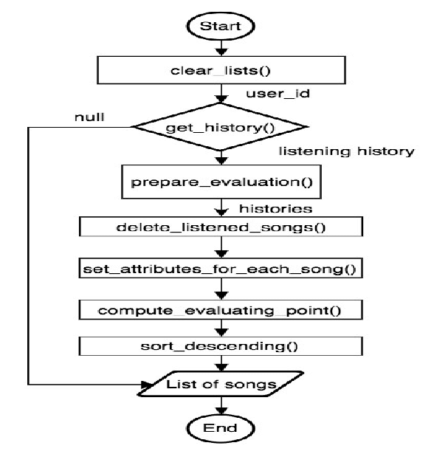

III. Methodology: This study applies various recommendation methodologies to develop a playlist recommendation system. Data preprocessing includes steps such as removing incomplete records, normalizing song features, and encoding categorical variables. The study then employs three main recommendation techniques:  
1. Collaborative Filtering - This includes user-user and item-item similarity, typically based on cosine similarity or Pearson correlation to find patterns in user behavior.  
2. Content-Based Filtering - Attributes such as genre, artist, tempo, and other audio features are analyzed. Deep learning models, like Convolutional Neural Networks (CNN), are often utilized to extract song features, which are then compared to recommend similar tracks.  
3. Hybrid Models - These combine collaborative and content-based techniques. This paper implements a weighted hybrid model, allocating preference weights based on the user history and similarity scores. Metrics such as precision, recall, and F1-score are used to evaluate the performance of each model.

**Challenges**

**Data Quality and Availability**:

**Challenge**: One of the primary challenges in building a music recommendation system is obtaining a high-quality, diverse, and representative dataset. The accuracy of collaborative filtering heavily depends on the richness of the data, which might not always be available or may require costly licensing agreements.

**Solution**: You may need to explore public datasets or collaborate with music platforms like Spotify or Last.fm. The system can also be designed to account for missing or sparse data using techniques like matrix factorization.

**Scalability**:

**Challenge**: Collaborative filtering algorithms can become computationally expensive as the number of users and songs increases. Scaling the system to handle millions of users or tracks can slow down processing and recommendation times.

**Solution**: Implementing more efficient algorithms such as neighborhood-based collaborative filtering or matrix factorization methods like Singular Value Decomposition (SVD) can help mitigate this issue.

**Cold Start Problem**:

**Challenge**: The cold start problem arises when there is insufficient data on a new user or song, making it difficult for the system to generate recommendations.

**Solution**: Hybrid recommendation models that combine collaborative filtering with content-based filtering (using song features such as genre, artist, or mood) can alleviate the cold start issue.

**Real-Time Recommendation**:

**Challenge**: Generating personalized recommendations in real-time based on user activity is complex, especially when the user’s preferences evolve dynamically.

**Solution**: Implementing efficient data processing pipelines and algorithms that update the user profiles in real-time will allow the system to generate up-to-date recommendations.

**Ethical Considerations**

**Privacy Concerns**:

**Concern**: Personalized recommendation systems require collecting sensitive user data, such as listening habits and personal preferences. The misuse or unauthorized sharing of this data poses significant privacy risks.

**Solution**: Implementing strong data encryption and ensuring that the data collection process is transparent (with user consent) can help mitigate privacy concerns. Allowing users to control the data they share also enhances trust.

**Bias in Recommendations**:

**Concern**: Collaborative filtering may reinforce biases if the data used to train the model reflects certain preferences or demographics, potentially leading to a lack of diversity in the recommended playlists.

**Solution**: Regularly auditing the system for bias and incorporating mechanisms that promote diverse recommendations can help reduce this issue.

**Over-Personalization**:

**Concern**: Over-personalized recommendations may lead to users being stuck in a "filter bubble," where they are only exposed to a narrow range of content that aligns with their existing preferences.

**Solution**: Introducing randomness or diversity in the recommendations can encourage users to explore new genres or artists, breaking the filter bubble and fostering discovery.

**Copyright and Licensing**:

**Concern**: Recommending music without proper licensing agreements or infringing on copyright laws can lead to legal issues for the developers or platforms.

**Solution**: Ensuring that all recommendations comply with copyright laws and partnering with licensed platforms to access music tracks legally is crucial.

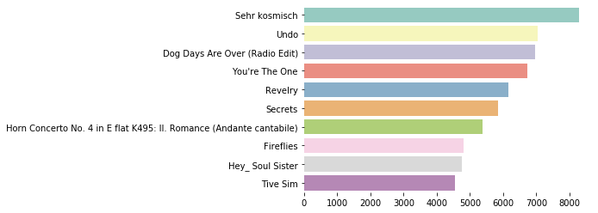

IV. Implementation and Algorithm Design

The algorithms for playlist recommendation systems were implemented using Python with libraries such as Scikit-Learn for collaborative filtering and TensorFlow for deep learning in content-based models. Collaborative filtering models use k-nearest neighbors (KNN) to identify and recommend songs based on user-user and item-item similarity. For content-based filtering, deep neural networks are trained to analyze song features such as tempo, pitch, and genre. The hybrid model integrates both methods by balancing collaborative filtering and content-based scores based on user preference and engagement.  
  
An example workflow includes:  
1. Data Preprocessing: Normalizing audio features and encoding metadata.  
2. Model Training: Training collaborative models with KNN and content models with neural networks.  
3. Integration of Results: Calculating weighted recommendations through hybridization.

V. Results: The results indicate that hybrid recommendation models outperform individual collaborative and content-based approaches in playlist generation accuracy. Evaluation metrics used included precision, recall, and F1-score. Results for each model 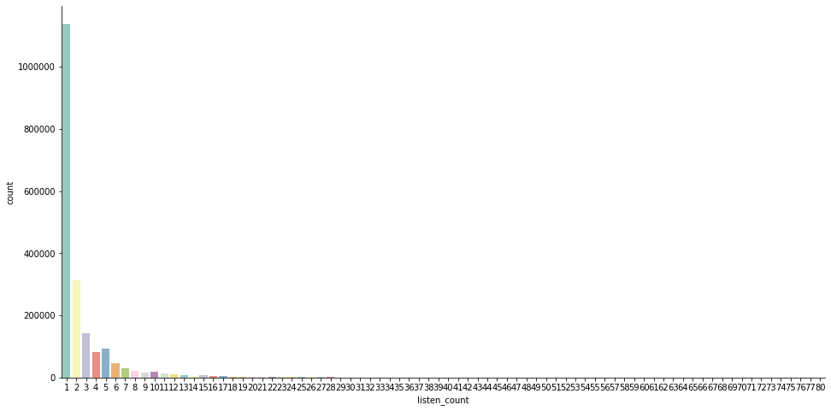are as follows:  
  
- Collaborative Filtering: Achieved high relevance for frequent users but struggled with cold-start problems.  
- Content-Based Filtering: Effective in recommending items with similar features but lacked personalization in certain cases.  
- Hybrid Model: Achieved the highest accuracy, with improvements in handling new user interactions due to a balanced approach between collaborative and content-based data.  
  
Figures 1 and 2 demonstrate performance metrics comparison across different models, with hybrid approaches yielding the most consistent results across user groups.

# VI. Evaluation Metrics

To assess the effectiveness of recommendation models, several evaluation metrics were employed:  
  
- Mean Absolute Error (MAE) and Root Mean Square Error (RMSE) for rating prediction accuracy.  
- Precision and Recall to evaluate relevance, with precision focusing on accurate recommendations and recall on completeness.  
- Coverage, which measures the proportion of items recommended by the system out of all available items, provides insights into the system's ability to expose users to diverse content.

# VII. Discussion

The study findings emphasize that hybrid recommendation systems are a robust solution to issues faced by collaborative and content-based models independently. Collaborative filtering provides personalized recommendations effectively but suffers from limitations like cold-start issues. Content-based models, by contrast, are resilient to cold-starts but tend to produce limited diversity in recommendations. By combining these methods, hybrid models capitalize on the strengths of each approach, providing diverse yet accurate recommendations.   
  
Future research could explore contextual recommendation systems, where user location, time of day, and activity are integrated to further personalize recommendations. The potential integration of reinforcement learning is also promising for systems that learn and adapt in real-time.

# VIII. Conclusion and Future Work

This research underscores the effectiveness of hybrid recommendation systems in enhancing the music playlist experience for users. By leveraging collaborative and content-based filtering, hybrid models provide a balanced recommendation system that meets user needs more holistically. Future work could focus on incorporating real-time user interactions and exploring reinforcement learning to create more adaptive and personalized systems. Additionally, integrating contextual data may further enhance recommendation quality, catering to dynamic user preferences and broadening the scope of personalized content delivery.

# References

[1]. Bobadilla, J., Ortega, F., Hernando, A., & Gutierrez, A. (2013). Recommender systems survey. Knowledge-Based Systems, 46, 109-132.  
[2]. Koren, Y., Bell, R., & Volinsky, C. (2009). Matrix factorization techniques for recommender systems. IEEE Computer, 42(8), 30-37.  
[3]. Ricci, F., Rokach, L., & Shapira, B. (2015). Recommender Systems Handbook. Springer.  
[4]. Burke, R. (2002). Hybrid recommender systems: Survey and experiments. User Modeling and User-Adapted Interaction, 12(4), 331-370.  
[5]. Hu, Y., Koren, Y., & Volinsky, C. (2008). Collaborative filtering for implicit feedback datasets. 2008 Eighth IEEE International Conference on Data Mining.  
[6]. McFee, B., Bertin-Mahieux, T., Ellis, D. P., & Lanckriet, G. R. (2012). The million song dataset challenge. Proceedings of the 21st International Conference on World Wide Web.